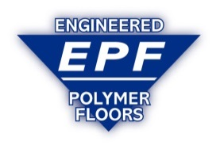

PUMA-CRETE® Urethane Mortar Flooring _______________________________________________________________________________________
Enhanced resistance to Chips, Spalls, and Impact:
PUMA-CRETE® handles repetitive scraping and scratching better than competitive systems.

Permanent Non-Slip Texture:
PUMA-CRETE® retains its texture, even as it wears.

Extreme Resistance to Thermal Shock and Thermal Cycling:

Withstands hot spills and repeated thermal cycling (hot washdowns, steam cleaning, etc.) without breaking down. (-50 to +250 deg. F) (-45 to +121 deg C)

Virtually No Odor:
PUMA-CRETE® has no VOC’s that can taint your product.

Fast Turn Around:
PUMA-CRETE HF is a one-pass mortar system. Projects can be completed thru weekends, with limited costly downtime.

Turn-Key Installation:

E P Floors is a vertically integrated company, manufacturing the materials, installation with our own crews, and a

comprehensive warranty. True turn key responsibility!

Long Term Durability:

Exclusive Five year Warranty.

Moisture Tolerant:

PUMA-CRETE® may be applied over damp surfaces. Withstands up to 12 lbs of vapor pressure passing thru the concrete slab, without delaminating, blistering, or cracking (Competitive systems are rated <5 lbs).

Temperature Tolerant:
May be installed in operating coolers at 35 deg F (1 deg. C) or above.

Chemical Resistance:
Excellent resistance to most solvents, acids and alkalis.
__________________________________________________________________________
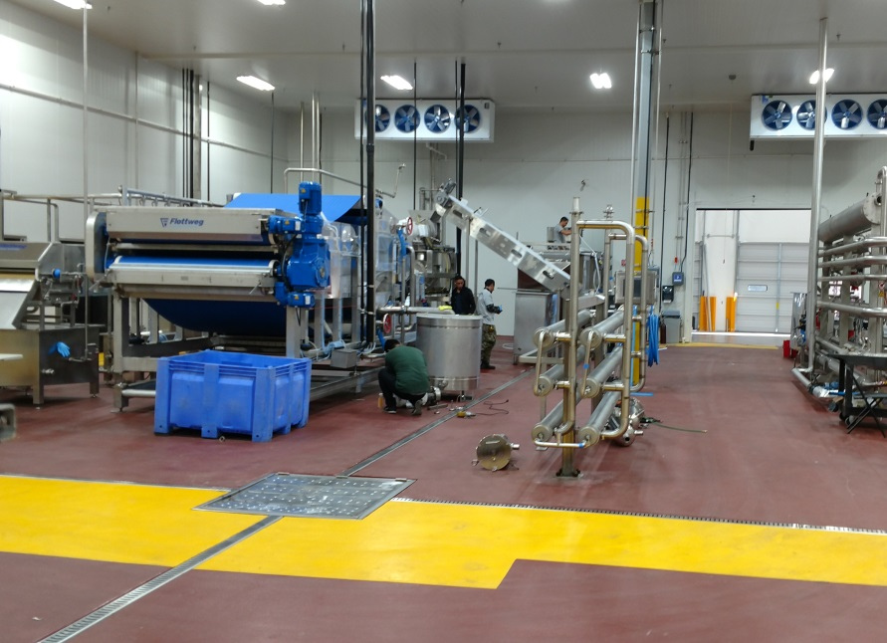
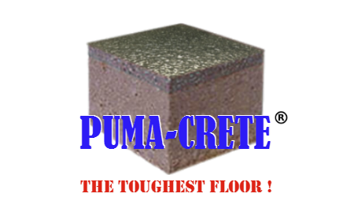
“Turn-Key Installation”

As an ISNetworld certified company, EPF has achieved the highest level of safety, training and insurance requirements that are required by the largest global firms.
www.EPFloors.com 1-800-808-7773
_____________________________________________________________________________________________
Boston ● Atlanta ● Washington ● Chicago ● Dallas ● Denver ● Los Angeles ● Seattle
West Indies/Caribbean ● Central America ● S.A. Outside the U.S.A +1 413 2835164

