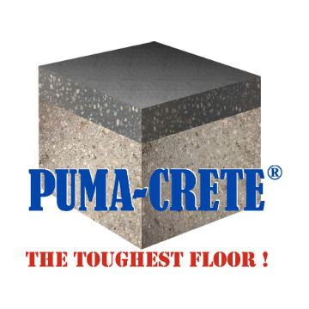

11.4.23
PumaESD Recommended Tools/Supplies
PumaESD TOOLS & SUPPLIES KIT …………… $ 639.00 Kit includes the following:

- Duct tape
- Tape. Blue 1.5”
- Painters paper- brown, 1-roll
- Mixer paddle 5-gal (spiral-liquids)
- Mixer paddle 1-gal (spiral-liquids)
- 5-gal pail
- Cotton rags
- Mix n Measure, 1-Quart qty- 4
- Mix n Measure, 2-Quart qty- 4
- Spike shoes-plastic, (tighten spikes securely)
- Roller frame 9” qty-2
- Roller cover 9” x 3/8” qty- 4 (purdy/wooster)
- Roller frame, 18” w end caps qty-1
- Roller cover 3/8” x 18” qty-2, (purdy/wooster)
- Brushes 2" qty-4
- Squeegee 18” by Unger (pull)
- Squeegee flat 18” gray (push or pull)
- Extension Pole 60"
- Conductive copper tape (grounding)
300 SERIES Only …Add $ 117.00
- Mixer paddle- (egg beater style - grout-mixes)
- Trowel, flat 4 x12”
- Roller cover, LOOP/textured 9” qty-3
- Roller cover, LOOP/textured 18” qty-3

_______________________________________________________________________________
Additional Basic Mixing Tools/Supplies required (not included w/ above tools/supplies).
- Variable Speed DRILL- ½” chuck or hvy duty Mud Mixer (for slurry systems) (Home Depot or similar)
- 5 GAL PAILS Estimated 3 buckets required, for every 1000 sf of area
- ACETONE (for cleanup of tools)
- 4 or 6 mil Plastic and rosin paper/cardboard for mixing area.
_________________________________________________________________________________________________
300 SERIES ESD Systems (SLURRY SYSTEMS)
Spread with trowel, cam rake and/or notched squeegee.
- CAM RAKE OR NOTCHED SQUEEGEE (Spreading the Slurry Coat) For large wide open areas, slurry coat may be spread using a Cam Rake (MidWest Rake Co.) or notched squeegee. The 24” cam rake requires #2 (1/8”) or #3 (3/16”) cams. It spreads the materials without requiring hand troweling in the main areas. Edges/perimeter always require hand troweling.

- 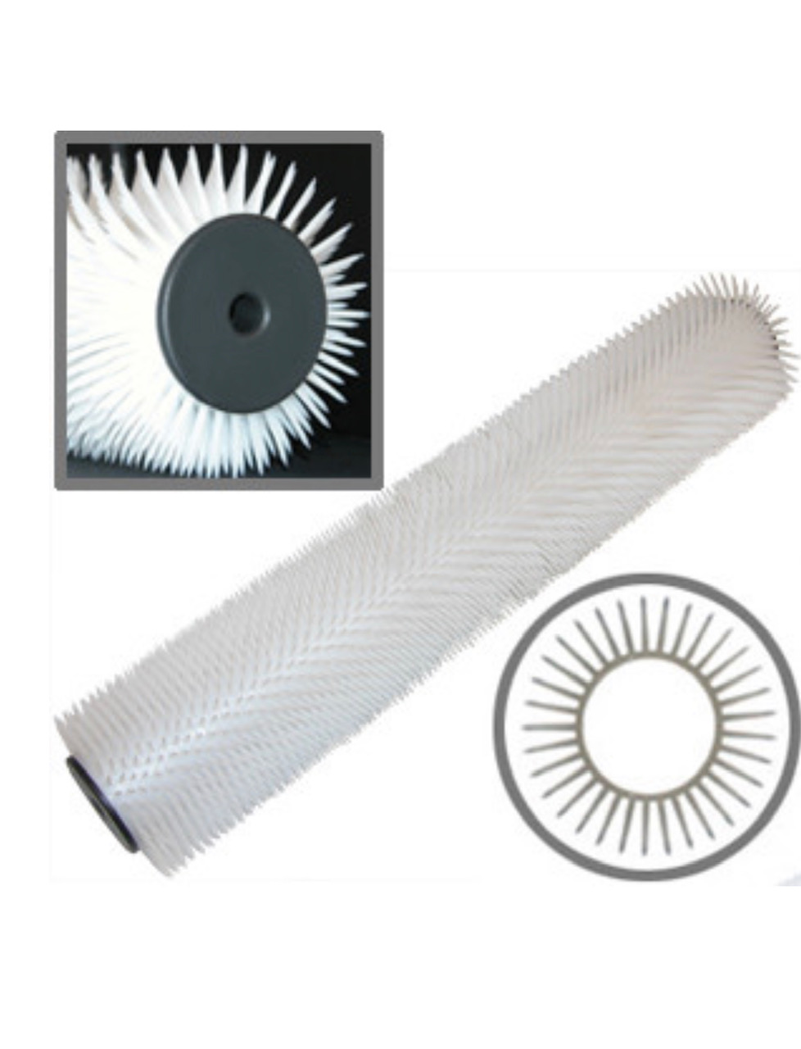NOTCHED SQUEEGEES ………………………………………………………………….. $ 25.67
1/2” NOTCH (blade/frame)– applies slurry at 1/8”
3/8” NOTCH (blade/frame)– applies slurry at 1/16”

- SPIKE/Porcupine ROLLER: ……………………………………….….……. $ 95.26 Use for rolling 3/16” to ¼” slurry base coats

- MINERAL SPIRITS (increase working time of 300/400 series) Use only if substrate/materials are out of proper temperature range (70-80 deg F), or you need more working time. (up to 8 oz/unit for 300/400 series urethane concrete mortar/slurry)
SQUEEGEES for THIN MIL & HI-BUILD COATINGS
EZ NOTCHED SQUEEGEE 18” - BLADE only ……………………. $ 25.67
MIL SIZES
5- 7 (yellow)
8-12 (red)
15-20 (green)
45-50 (orange)
50-60 (purple)
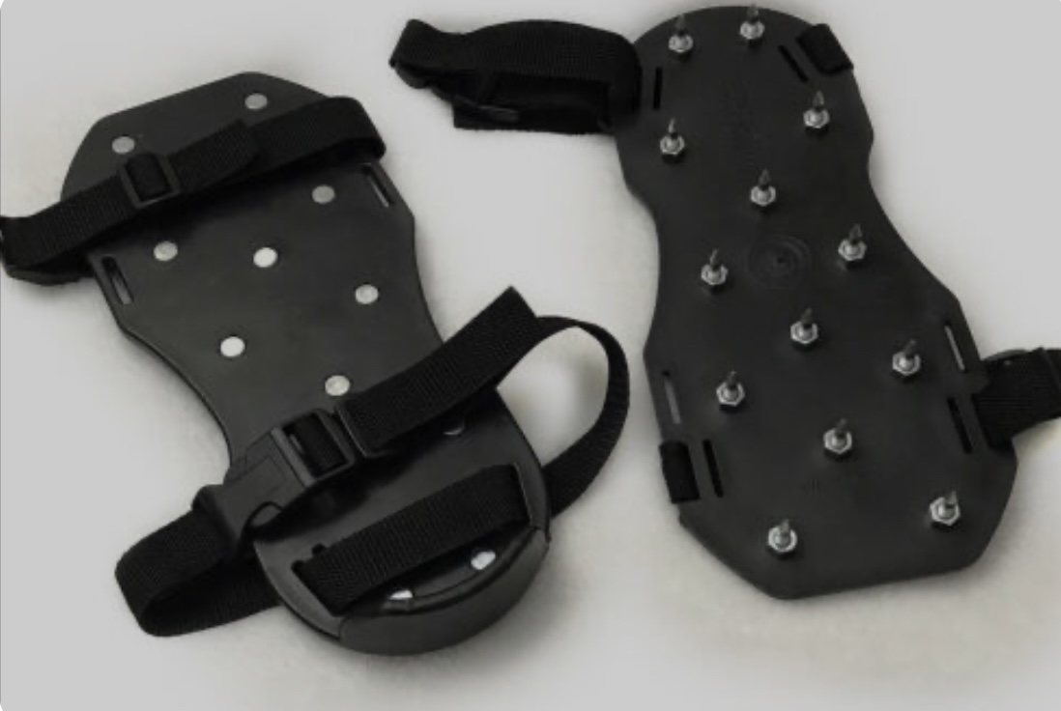
EZ NOTCHED SQUEEGEE 18” - FRAME only..……………… $ 46.70

SPIKED SHOES …………………………………………………… $ 39.00
Strap/tape to bottom of feet
Allows you to walk in the wet materials.
___________________________________________________________________________________________
PREP TOOLS
Fits 17” floor buffer machines (a/k/a FLOOR MAINTAINER, FLOOR MACHINE, SWING MACHINE)
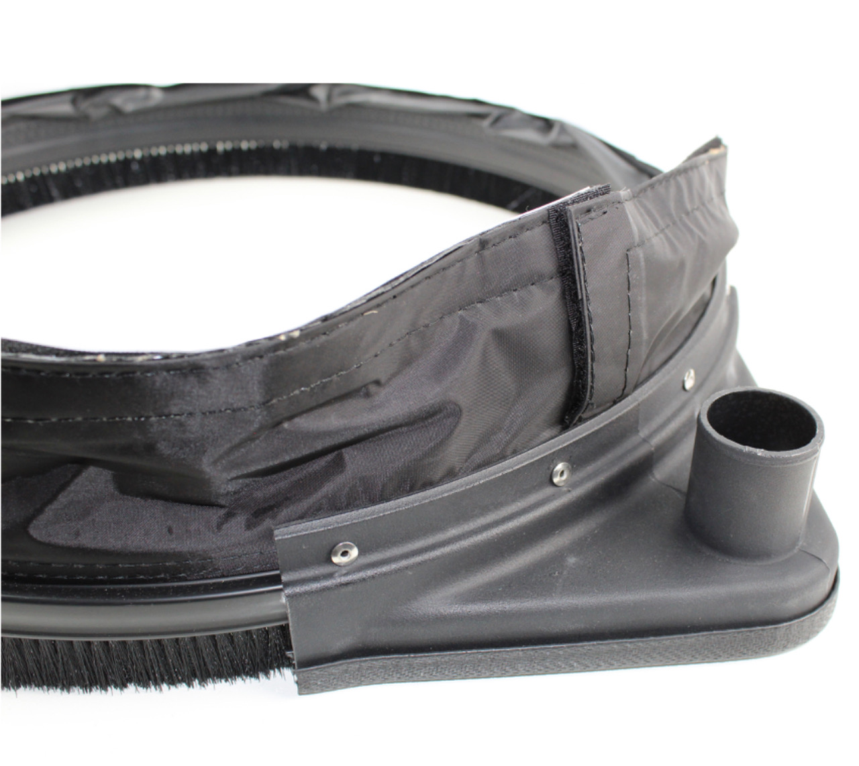
DUST SKIRT ………………………………………………………………………….… $139.00
Minimize dust, using this skirt that attaches around the base of
floor buffers. Fits all 17-inch floor machines using a velcro
strip attachment). Features a 1.25-inch inch dust port for
vacuum hose connection.

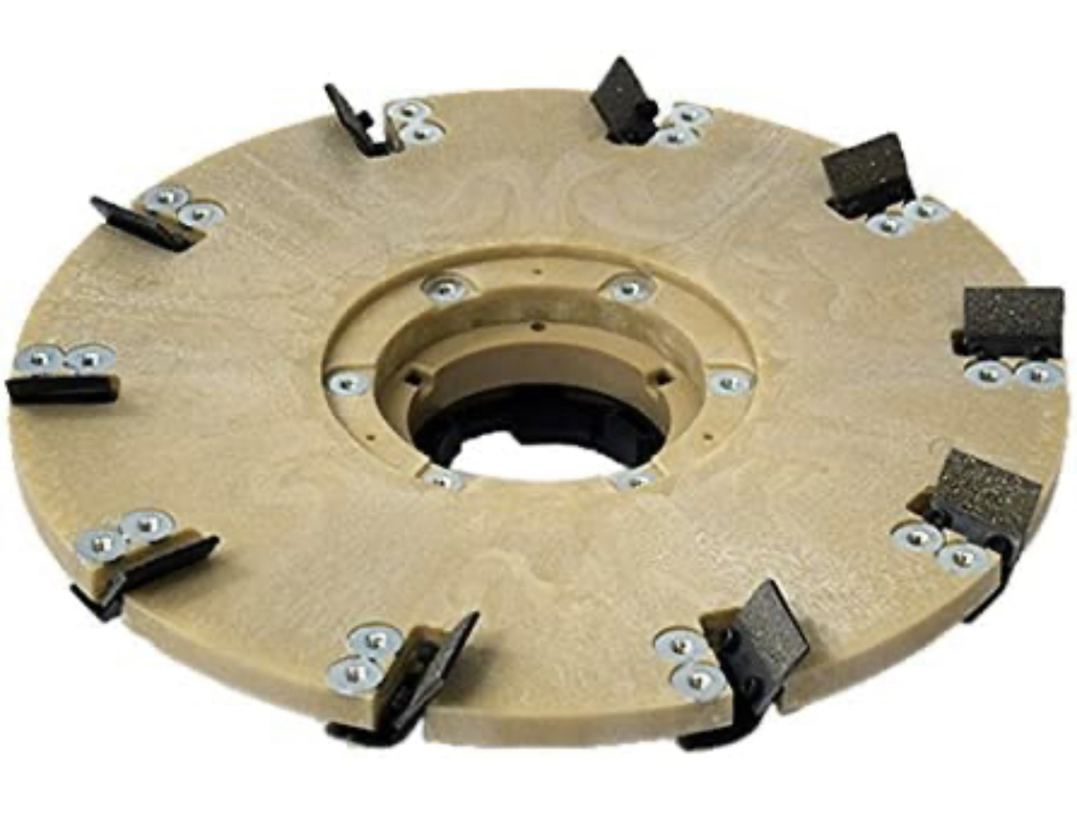
REMOVAL TOOL, 16” DIAMABRUSH…………………………………… $849.00
Diamond scraper tool, designed for removal of glue, mastic,
and 2-3 mil coatings.
Includes 1.5” riser and standard clutch plate.

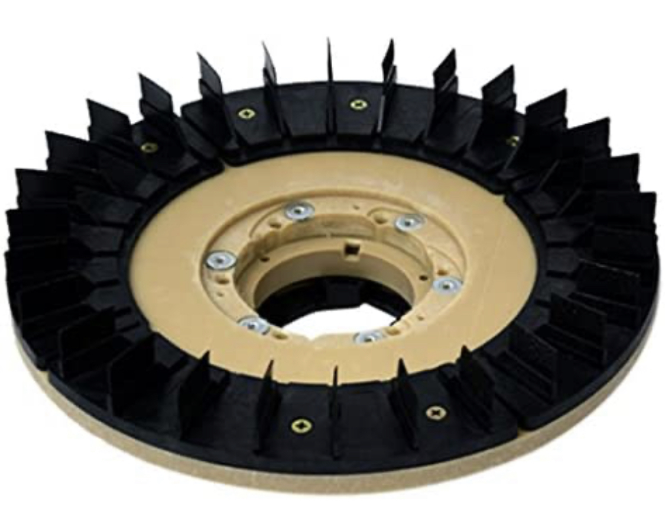

PREP TOOL, 16” DIAMABRUSH ……………………………………….. $ 875.00
25 grit diamond disc shroud
Includes 1.5” riser and standard clutch plate

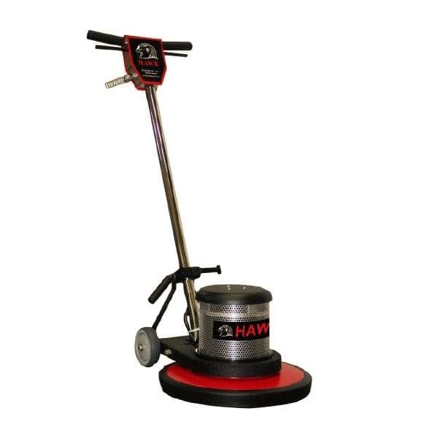

FLOOR MACHINE ……………………………………………………..….. $1,567.00
17” FLOOR BUFFER MACHINE
Hawk F0003-17XHD or similar

ADDITIONAL TOOLS (for LARGER SLURRY PROJECTS)
Battery Powered Quartz Blower/Broadcaster (Dewalt)……………………………………………………$ 985.00
110v corded, Quartz Blower/Broadcaster ………………………………………………………….………… $ 840.00
Gas, Backpack Quartz Blower/Broadcaster……………………………………………………………………… $ 1,230.00
4.3 hp low emissions 2 stroke engine, 50 lb hopper capacity, 35 ft horizontal reach,
800 cfm, 23 lb, 1 gal fuel tank, (use 50:1 pre-mix fuel)

ESD Anti-Static Floor Supplies
3M 701 Megohmmeter Resistance Test Kit, with Case…………………………………………………… $ 973.00
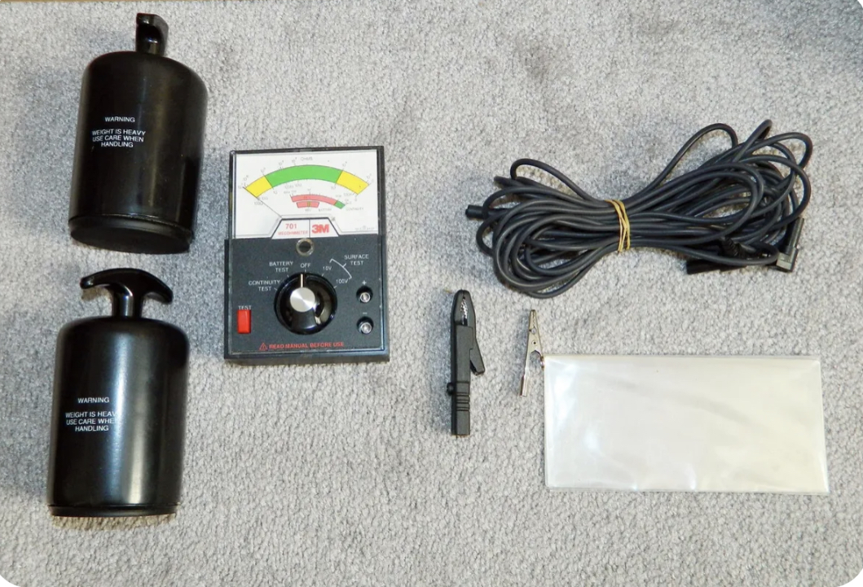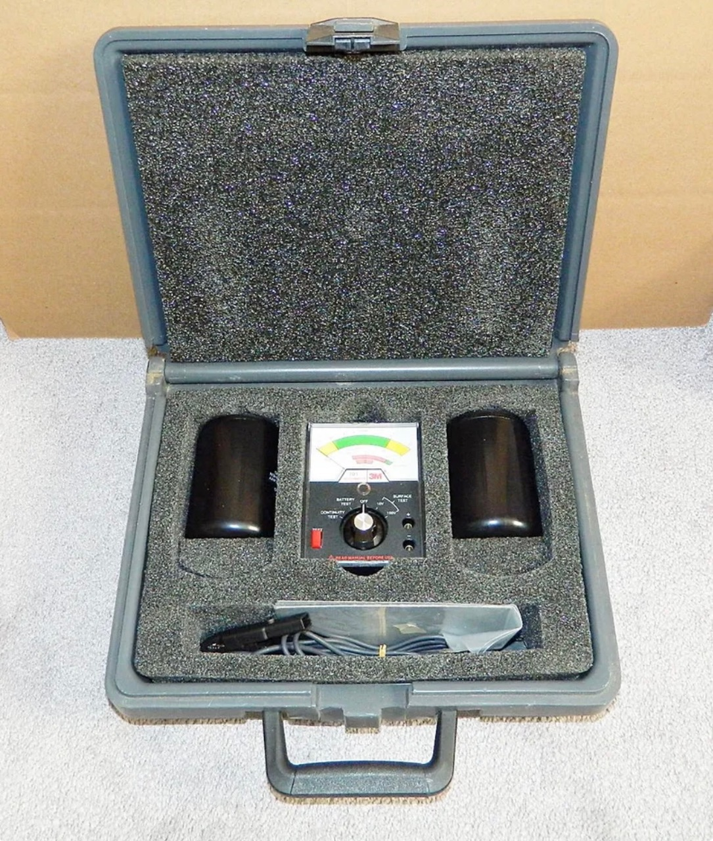

Rental Only: ………………….. $198.00
plus freight (includes 1 week)

